HP Quality Centre 11 – What’s new?
www.infosys.com
HP is the market share leader in the Worldwide distributed testing market in 2011*. The recently released version of
the HP 11 products suite (HP Application Lifecycle Management (ALM) 11.00 and HP QC 11.00) further reinforces HP’s
market dominance in this space going forward and will ensure that it retains its position as the leader of the pack for the
foreseeable future.
1. HP Quality Center 11 (QC 11) enables traditional users to integrate Business Process Models with business requirements,
2. Provides a rich text editor for maintaining business requirements in MS Word format, and also helps share reports
through the web or MS SharePoint portals. For Agile users,
3. QC 11 goes a step further by provisioning for integration of test outputs with user stories and tasks. From a system administrator’s perspective,
4. apart from providing tools for better space maintenance and system performance monitoring,
5. QC 11 also mitigates risks during migration by allowing multiple clients to connect to lower (or older) versions alongside QC 11.
Let us take a closer look at HP’s QC 11 line-up and the lead features of the enterprise edition with a special focus on the
reloaded HP Sprinter feature.
* Source: Gartner, “Market Share: All Software Markets, Worldwide, 2011” 29 March 2012
02
|
Infosys

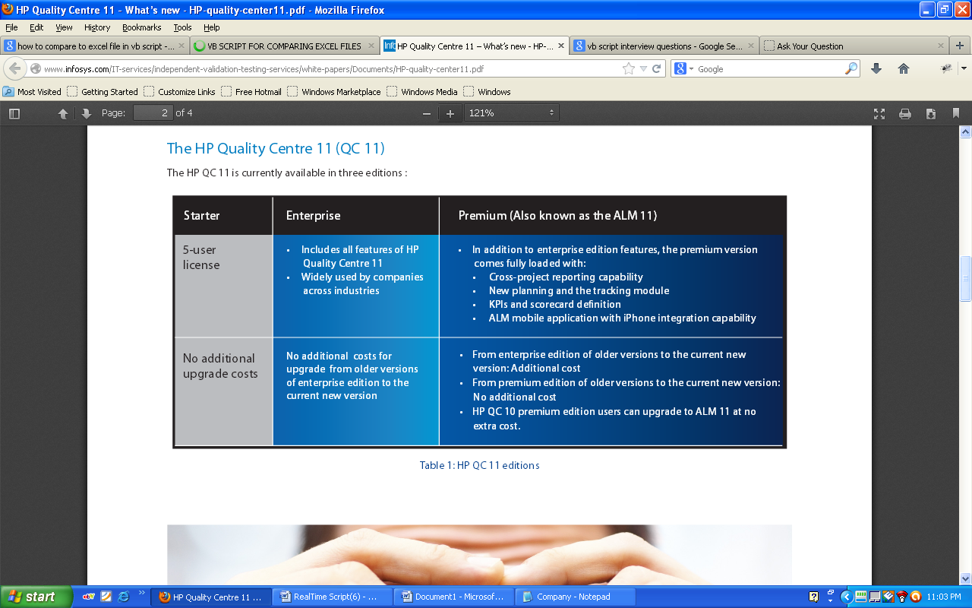
What’s new in HP QC 11 - Enterprise Edition?
Nearly 80% users of HP QC 10 work with the enterprise edition. Here are some features of HP QC 11 that make it an interesting business
case for an upgrade:
•
The HP Sprinter module
: This module can dramatically improve productivity in manual testing. Sprinter is fully integrated with HP
ALM, enabling you to maximize the benefits of both solutions. It provides advanced functionality and tools to make manual testing
execution more efficient and effective.
•
Project Planning and Tracking module
: This is an advanced module that integrates test execution management with test project
management. Note: For most scenarios with established test delivery processes, this module may not be of much value to most users.
•
Sprinter’s Mirror Testing feature
: This feature enables users to run tests in different browser environments (Internet Explorer, Firefox,
Safari, etc.). The record and replay functionality of Sprinter offered in this version makes it a desirable feature that may be developed
further in future releases.
Infosys

Accelerate manual testing with HP Sprinter
HP Sprinter could be your answer to productivity challenges testers encounter during manual testing.
With HP Sprinter you can :

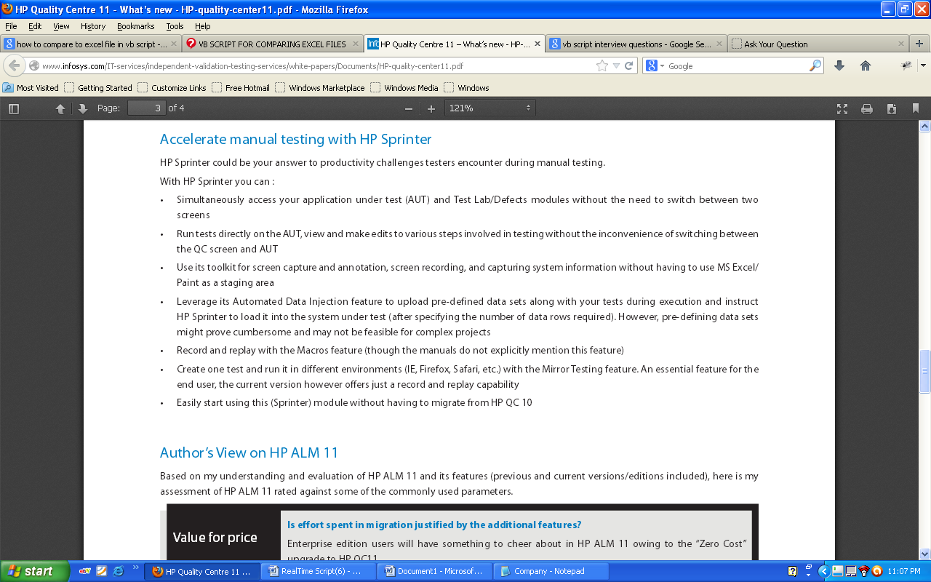

Author’s View on HP ALM 11

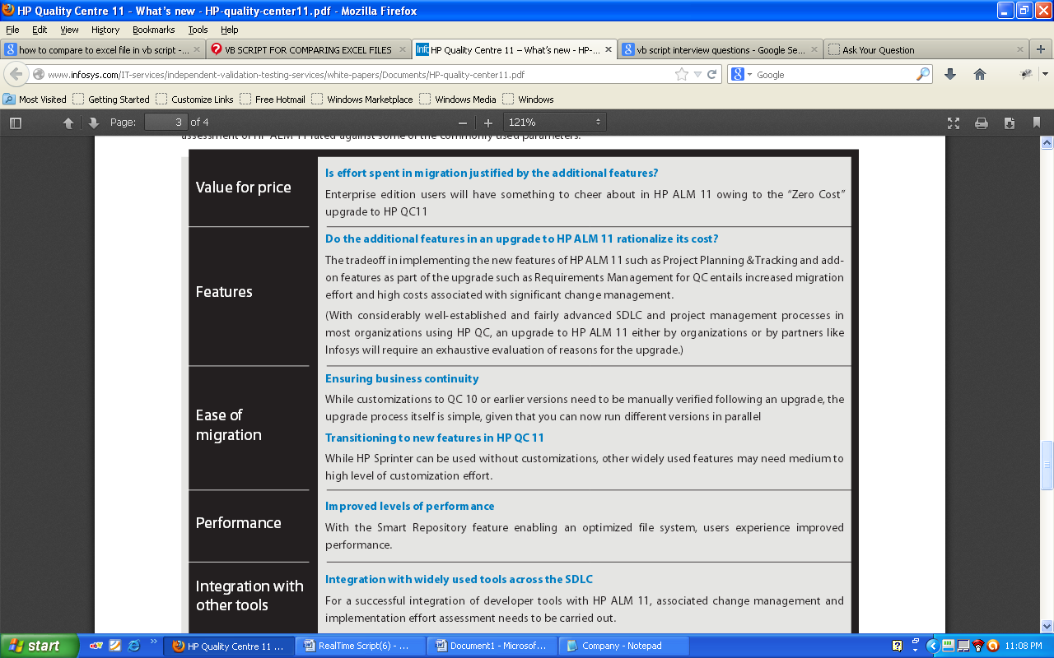

We delivered in QC 10
- New Version Control functionality
- New Project Baseline functionality
- New Management module (includes former Releases module)
- Expanded Business Components module
- New Test Resources module
- New Dashboard module for centralized reporting and dashboard views
- Changes to module tabs
- Changes to module menus and buttons
- Miscellaneous usability improvements
From QC10 to QC 11
We delivered :
- Installation Wizard: Validations have been added throughout the installation process. The installation wizard now consists of two stages: file delivery and server configuration. This means that you can reconfigure the server without having to reinstall the application. Also in the installation we have implemented Data Security that encrypts information for accessing external systems (databases, LDAP), and secures communication with other HP BTO applications. Finally installing an ALM client no longer requires administrator privileges on the machine.
- Optimized Project Repositories: project files are now saved over an optimized repository system that ensures better performance for common actions, and extends the capacity of the file system. Files in the project repository are stored in an optimized folder structure that allows maximum storage space.
- Side-by-Side ALM Clients: multiple clients at a time
- Business Process Model Integration: under requirement module.
- Traceability Matrix
- Test Configurations
- New Manual Runner - HP Sprinter

HP ALM 11 also has the following components/functionality:
- Project Planning & Tracking - Leverage ALM data to create KPIs and track them against key project milestones
- Cross-project reporting - Aggregate metrics and trends across multiple projects providing a holistic view.
- Asset Libraries (Requirements and Tests) for sharing and reuse across multiple projects
- Centralized Process Standardization - Create centralized templates to standardize and enforce workflows/process across multiple projects.
- Defect Sharing - Share defects across multiple projects (Helpful where an application touches multiple projects or where a developer wants all their defects from multiple projects in one view)
- The High Availability Server (Optional purchase for QC) to allow for scalability across large enterprises is included at no extra cost

